A STUDY ON VARIOUS GREEN HUMAN RESOURCE MANAGEMENT PRACTICES IN ORGANITATION
Mr.SANTHOSH ACHARI V
M.COM NET
LECTURER, DEPT. OF COMMERCE
SRI BHUVANENDRA COLLEGE, KARKALA
UDUPI DISTRICT,KARNATAKA,INDIA
EMAIL: santuseethanadi@gmail.com
ABSTRACT
Green Human Resource Management (Green HRM) as a research field includes all aspects and practices of HRM that pursue the goal of environmental sustainability. The aim is to reconcile the goals of companies and society without compromising financial performance. Green HRM is the integration of corporate environmental management into human resource management. Green HRM as a term is used to all possible HR policies that could contribute to an organizations environmental agenda. Green HRM involves undertaking environment friendly HR initiatives resulting in organization. Red apple Inc. is a global provider of IT& process out sourcing services. Objective of the paper is to know about the various green HR practices fallowed in an organization. Analyze the effectiveness of green HR practices. And to interpret the outcomes after adopting the green HRM practices in the organization. This study reveals secondary data. This paper aims to understand the concept of green HRM and to study the green HRM practices in the organization.
KEYWORDS
Green HRM, Green HRM practices in red apple Inc.

INTRODUCTION
Now a days the green HRM green polices are adopted in various management techniques.in India the corporate world is going global it become essential to explore green practices in business organization. Today, the green polices are implementing in each sector to reduce environmental issues. In human resource management, the green polices are developed to preserve their resource for future enlargement of the company along with society too. Companies now become conscious that they build up a prevailing social conscience and green sense of dependability where corporate social accountability is not just a brand building tool to have, but it has become a factor crucial tool to business.

OBJECTIVES
- To know about the various green HR practices fallowed in an organization.
- To analyze the effectiveness of green HR practices.
- To interpret the outcomes after adopting the green HRM practices in the organization.
METHODOLOGY
This study reveals secondary data is collected from various journals, articles, websites, and Test books.
LIMITATIONS
Secondary data
- Official websites of company
- Sustainability reports of company
- Result of the study based on the view of authors

CONCEPT OF GREEN HRM
Green HRM is the use of human resource management polices to promote sustainable use of resources with in business organization and more generally promotes the cause of environmental sustainability. Green HRM involves undertaking environment friendly HR initiatives resulting in greater effectiveness, lower cost and better employee engagement and retention in turn. The green human resource management comprises of many functions in the human resource department of an organization it helps to reduction of paper usages and implementation of green human resource polices such as planning, recruiting, selecting, managing employees and the employee relations. It makes the environment green in the workplace. Green HRM activities enhance the value of the employees and the company.
IMPORTANCE OF GREEN HRM
Green HRM is important for all over the world. The ecological consciousness of each human drives the living style and environment. The general employees are interested in green human resource management because of its important and need in the current workplace. The corporate world is the significant in enhancing the environment issues and the corporate has to give solution to these hazards.
Introduction to Red Apple Inc.
Red apple Inc. is a global provider of IT& process out sourcing services. Our management members have extensive experience in managing large IT applications in real time as well as in providing high value services. Our customers enjoy high value services with optimized cost of ownership.
We are an experienced young company. Our varied talent base guarantees value beyond customer & partner expectations. We believe in “customer delight” and believe in consistent delivery of the same.
Green HRM IN RED APPLE INC,
In red apple Inc., involves undertaking environment friendly HR initiatives resulting in greater effectiveness, lower cost and better employee engagement and retention in turn. The green HRM comprises of many functions in the HR Department of the red apple company. It helps to reduction of paper usages and the implementation of green HR practices such as planning, recruiting, selecting, managing employee and the employee relations. It makes the good environment green in the workplace. All the Red Apple Inc. companies activities involved in the green HRM enhance the value of the employees and the company
FUNCTIONS OF GREEN HRM
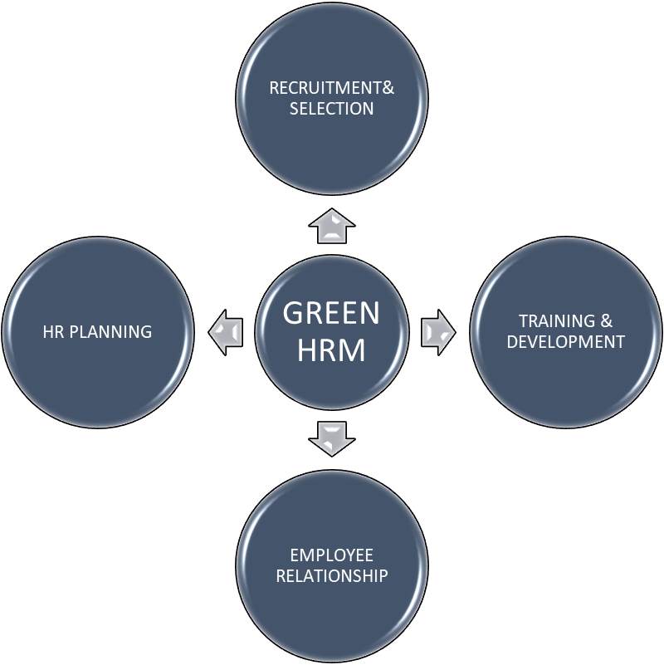

Green HR planning
Green HR practices start with the adoption of green HR planning. At present company engage in forecasting number of employees and types of employees, needed to implement corporate environmental management activities in the organization.
Green recruitment:
Green recruitment is practices in the red apple paper free recruitment process with minimal environment impact. Green recruiting is a system where the focus is given on importance of the environment and making it a major element within the company. Recruitment practices can support effective environmental management by making sure that new entrants are familiar with an organization environmental culture and are capable of maintaining its environmental values. The recruiters can carry out the green policies as well as the corporate policies in the management in establishing green policies to achieve the goals of the company.
The statements we can conclude that green recruitment provides the employer with an opportunity to stand ahead of the crowd and further increase their chance of attracting the candidates and retain them after induction. Recently the green trend makes the recruitment as environmentally friendly issues. The recruiting makes the employee green in achieving the environmental goals and how they perceive the job and parameters of sustainability as claimed.
Green Training and development
The green training and development is a practice in the company that focuses on development of employee’s skills, knowledge and attitudes. The green training and development educate employees about environmental management and training should be given for the employees to educate also about energy, reduce waste, and diffuse environmental awareness in the organization. This green training and development help employees to provide opportunity to engage employees in environmental problem solving.
In this study we can conclude that they can train employees on best business practices with green initiatives. So, this will enhance the organization and in person as well. Moreover, the employees can educate their customers about the advantages on becoming earth friendly and buying green products.
Green employee relations
In red apple Inc., will employee relations be one of the important aspects to establishing good natured employer and employee relationship. Through this employee relations, the motivation and morale of individual employee will increase and it enhances the empowerment activities.
We suggest that keeping the policies in place, long-term trust between the administration and workers will be built which will afford an opportunity to the employees to communicate their individual ideas at workplace.

GREEN HRM FUNCTIONS PRACTICES
HRM FUNCTION | GREEN PRACTICES
RECRUITMENT | To communicate the employer’s concern about through recruitment efforts.  To include environmental criteria in the recruitment messages.
SELECTION | To select applicants who have been engaging in greening as consumers under their private life.  To select application who are sufficiently aware of greening to fill job vacancies.
TRAINING | To impart right knowledge and skills about greening to each employee through training program exclusively designed for greening.  To do training needs analyses to identify green training needs of employees
EMPLOYEE RELATION | Through this employee relations, the motivation and morale of individual employee will increase and it enhances the empowerment activities.
HR PLANING | Engaging in deciding strategies to meet the forecasted demand for environmental works

CONCLUSION
Green HRM can adopt various green practices in different HR functions like HR planning, recruitment and selection, training and development, performance management and better relationship have an overall achievement of the organization goals.HR has significant opening to put in to the organization’s green movement and plays significant role in enthusing, facilitating, and encouraging employees for captivating up green practices for greener business.

REFERENCES
- Armstrong, M. (2009). HR policies procedures and systems. Armstrong’s Handbook of Human Resource Management Practice, 11th ed., 985-1015.
- www.redappleinc
- file:///C:/Users/HP/Downloads/global%20senario.pdf
https://www.researchgate.net/publication/328277326_Green_Human_Resource_Management_A_Review
- https://ejmcm.com/article_6324_a81d0382759ddb6341065867923d7728.pdf
- http://sro.sussex.ac.uk/id/eprint/81260/4/BSE-GHRM%20and%20Green%20Organizational%20Culture-Revise%20and%20Resubmit%20%28FINAL%29.pdf
- https://www.scribd.com/presentation/389486321/Green-Human-Resource-Management-pptx

